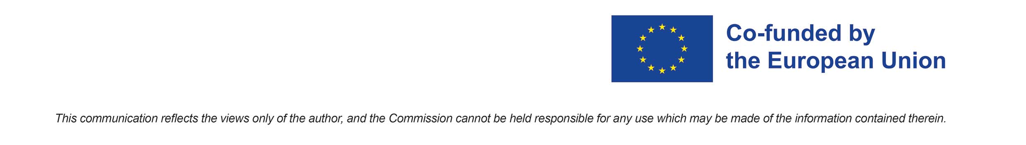
Youth and Fake News: Knowing how to recognize the Truth! FAKE2022 Project
ERASMUS+ 2021-2027 - KA1 Mobility - Youth Exchange - REF N. 2021-2-IT03-KA152-YOU-000038468

Partnership
Municipality of Verrone - Italy (Applicant)
AYES – Croatia (Partner)
Agoraveiro – Portugal (Partner)
Bokra Sawa – France (Partner)
Mladì Obcanè – Czech Republic (Partner)

Daily Programme

1° day – August 5, 2022
Morning + Afternoon:
- Arrivals of foreign delegates at Verrone
- Accommodations of all participants in the gym in Verrone, via dei Gorghi n. 5

Late afternoon:
- around 18.30: Opening of the Erasmus+ Youth Exchange FAKE2022 project. Place: Hall of the City Council, Via Castello n 2 at Verrone
- Welcome Ceremony
- Welcome speech from the Municipality of Verrone
- Presentation of Erasmus Plus Programme and introduction to “FAKE2022” project
- Buffet dinner

Evening:
- Transfer to the gym in Verrone for the night.

2° day – August 6, 2022
FAKE2022: Launch of the Erasmus+ Youth Exchange
Morning + Afternoon: at Museum Falseum in Verrone, Via della Valletta n. 1 (www.falseum.it):
- Welcome speeches. Presentation of Lead Partner and beneficiaries.
- Presentation of each Delegation
- Team building session
Lunch.
Afternoon:
- Guided tour of the Museum Falseum
Evening:
- Dinner with local food and tastes in Cerrione, at Restaurant Cascina Fontana, via Zanga n. 8 (www.cascinafontana.it).

3° day – August 7, 2022
Morning + early afternoon: at Museum Falseum in Verrone, Via della Valletta n. 1 (www.falseum.it):
- Creation of the Working Groups and start of the works on the assigned topics.
- Joint meeting, reflections and team building
- Presentation of “YouthPass and the 8 Key Competencies”.
Lunch.
Late Afternoon: in Borriana by car
- Briefing led by the Youth Leaders
- Guided tour of Borriana, pizza and music night
- Return to Verrone for the night

4° day – August 8, 2022 Saturday
Morning + early afternoon: at Museum Falseum in Verrone, Via della Valletta n. 1 (www.falseum.it):
- Group activity on the assigned topics
- Joint meeting and reflections.
Lunch.
Late Afternoon: in Benna by car
- Briefing led by the Youth Leaders
- Guided tour of Benna, dinner
Evening:
- Cineforum (open event)
- Return to Verrone for the night

5° day – August 9, 2022 (ALL DAY IN VERRONE)
Morning + early afternoon:
- Activities on the assigned topics. Joint meeting, reflections.
- Preparation of the debate scheduled for Day 6, August 10.
Lunch
Late afternoon:
- Briefing led by the Youth Leaders
Evening:
- Free time
- Return to Verrone for the night

6° day – August 10, 2022 (ALL DAY IN VERRONE)
Morning + early afternoon:
- Recap of the activities and of the results
- Making of a clip to be shown on Day 7, August 11.
Lunch
Late afternoon:
- Briefing led by the Youth Leaders
- Compiling the YouthPass.

Evening:
- International dinner prepared by the delegates
- Debate with two journalists on the topic “Fake News” (open event)

7° day – August 11, 2022
Morning: at Museum Falseum in Verrone, Via della Valletta n. 1 (www.falseum.it):
- Workshop (open event): public presentation of the project “FAKE2022”, by the young participants
- Presentation of the intellectual outputs created and the results. Projection of the video clip.
- Other relevant speakers + Institutional speeches.
- Delivery of the YouthPass
- Closing of the workshop.
Lunch
Afternoon:
- Evaluation and follow-up by the beneficiaries and youth leaders.
- Filling in the Final Questionnaire.
Evening: in Candelo by car
- Guided tour of Candelo
- Dinner, farewell party
- Return to Verrone for the night

8° day – August 12, 2022
Morning: Final greetings.
Departures of participants. Return home.

